Soy

Soy
Tree Nuts   |  | Tree Nuts
Wheat   |  | Wheat
Gluten

Sulfites   |  | Sulfites
Gluten

Crustacean Shellfish  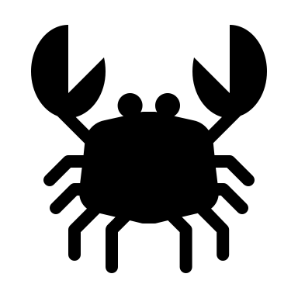 |  | Crustacean Shellfish
Eggs   |  | Eggs
Fish   |  | Fish
Milk   |  | Milk
Peanut   |  | Peanut
Lupin

Lupin

Sesame

Sesame
Mustard

Mustard
Molluscan Shellfish

Molluscan Shellfish
Tree Nuts
Tree Nuts
Wheat
Wheat
Gluten
Gluten
Sulfites
Sulfites
Celery

Celery

